# Intro

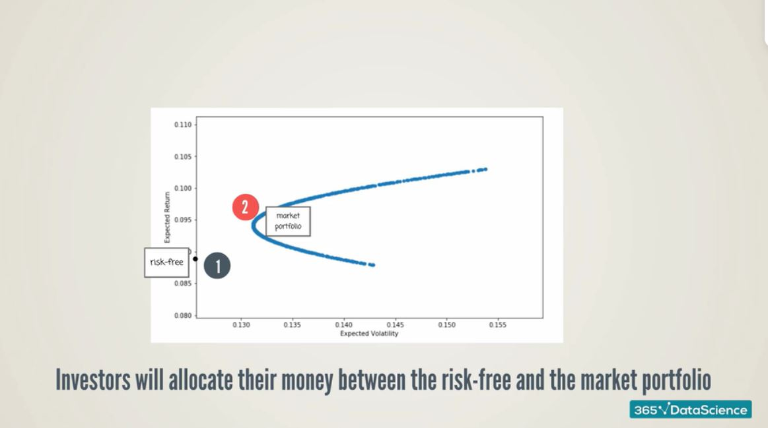

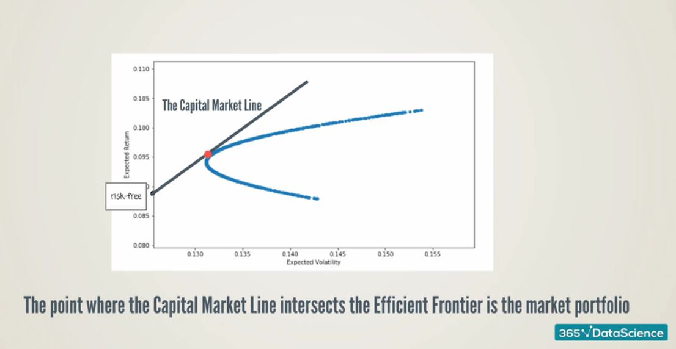



# Beta





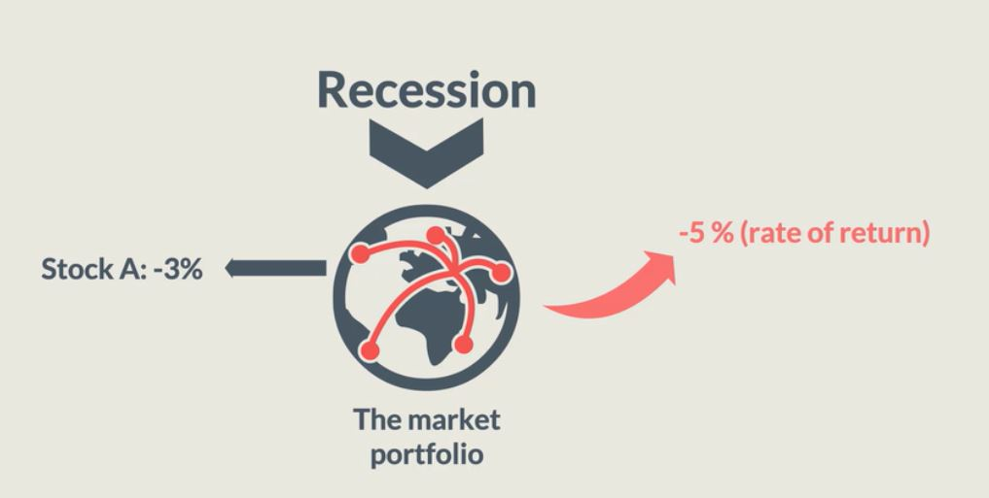

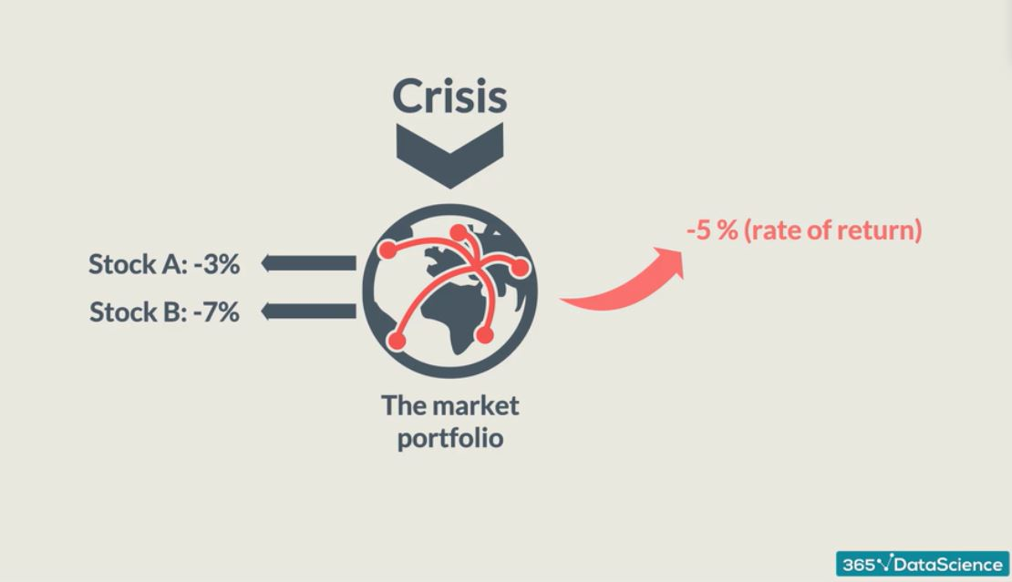

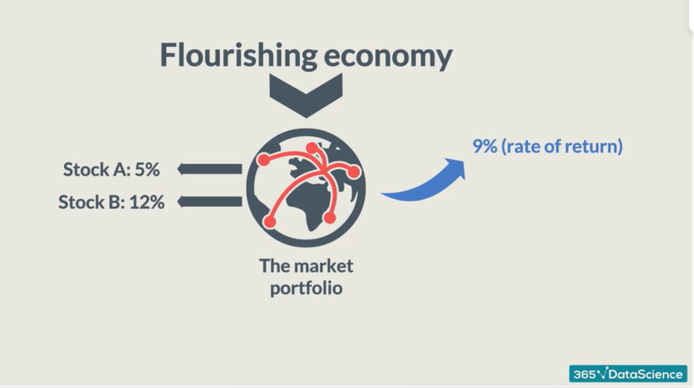



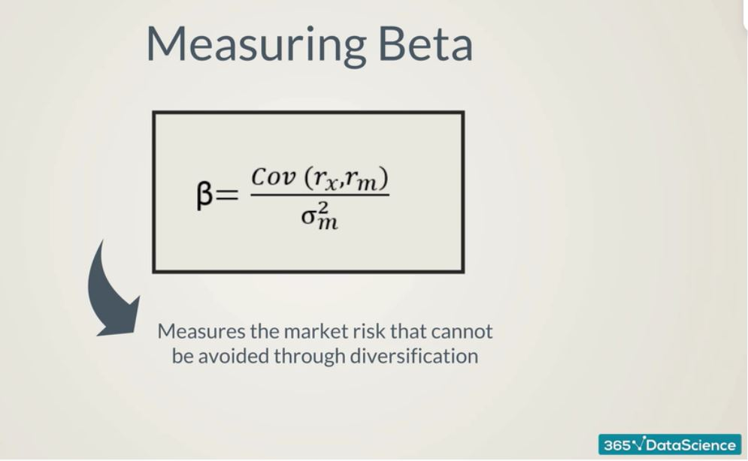

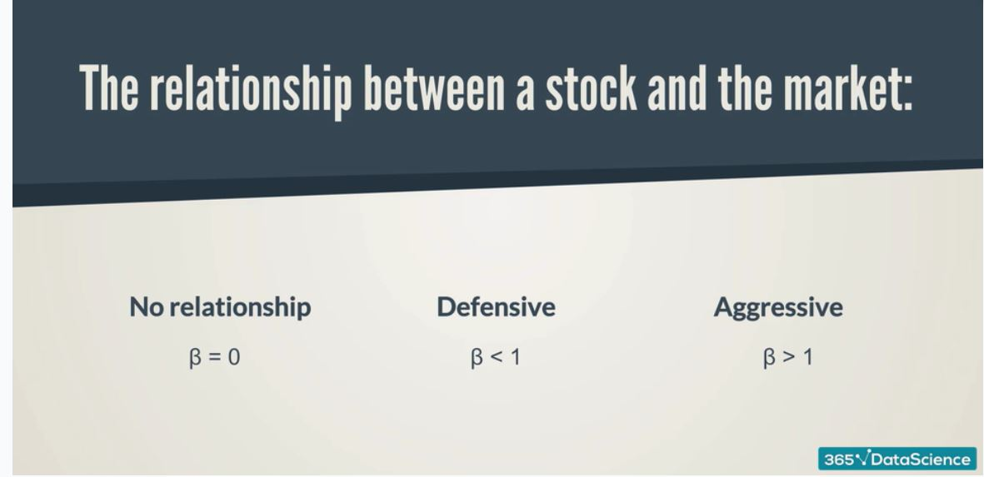

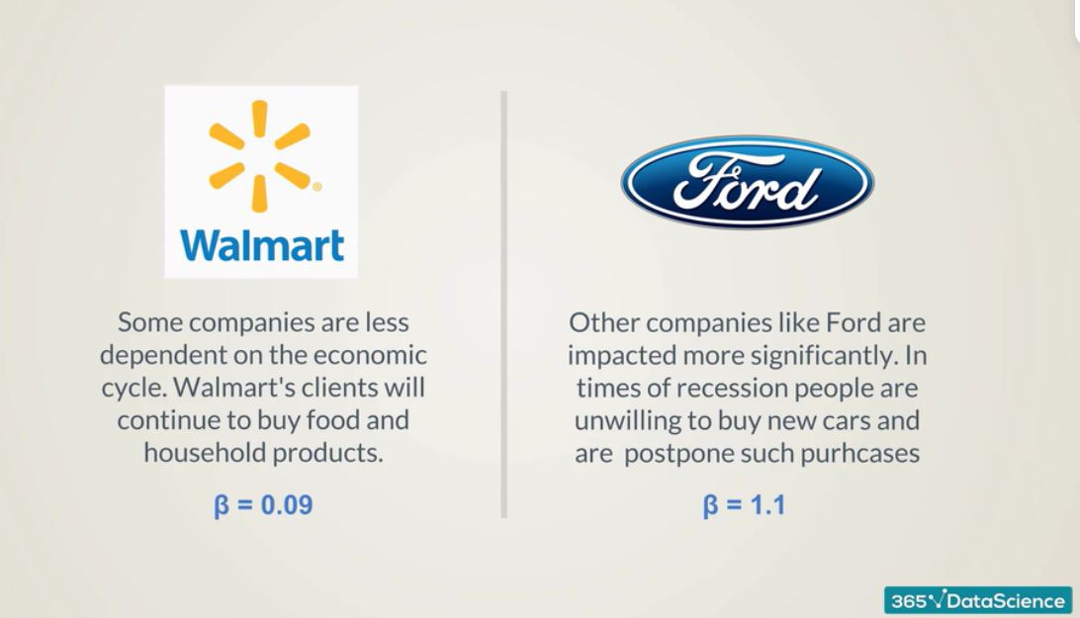

# CAPM Formula

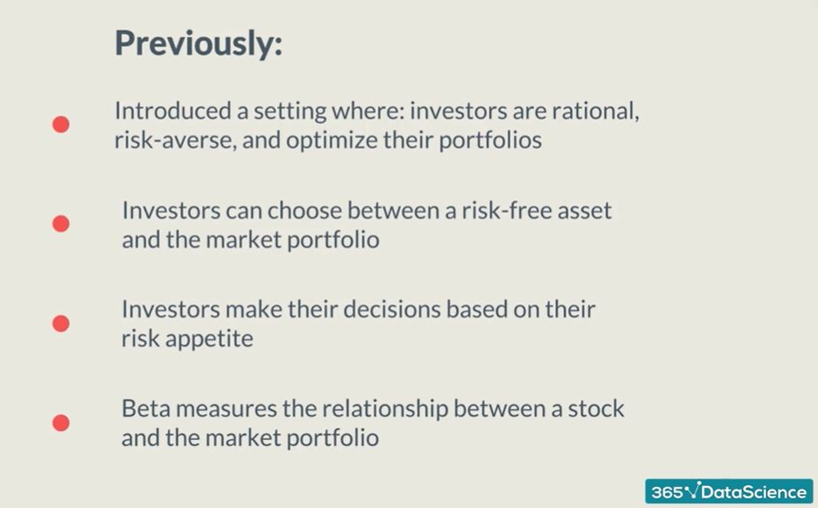

Firstly, we imagined that we live in the environment where all investors are rational, risk averse and willing to optimize their portfolios. Secondly, introduced the concept of market portfolio and risk-free asset. Thirdly, Investors make their decision based on their risk appetite (one seeking more higher expected return will allocate higher portion of money in market portfolio and less in a risk free asset). Fourthly, beta is introduced which measure how security is expected to perform regarding the entire market.

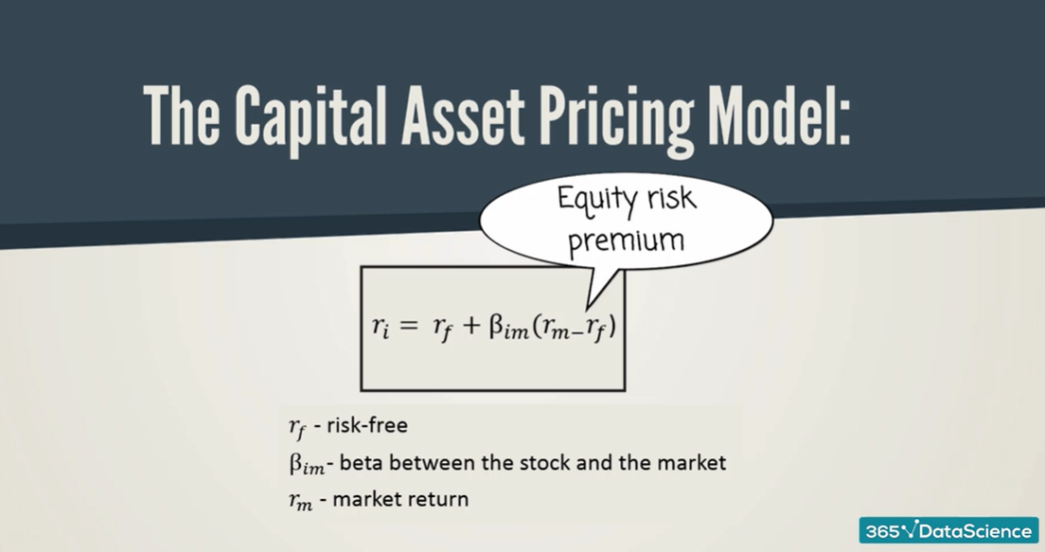

Most used



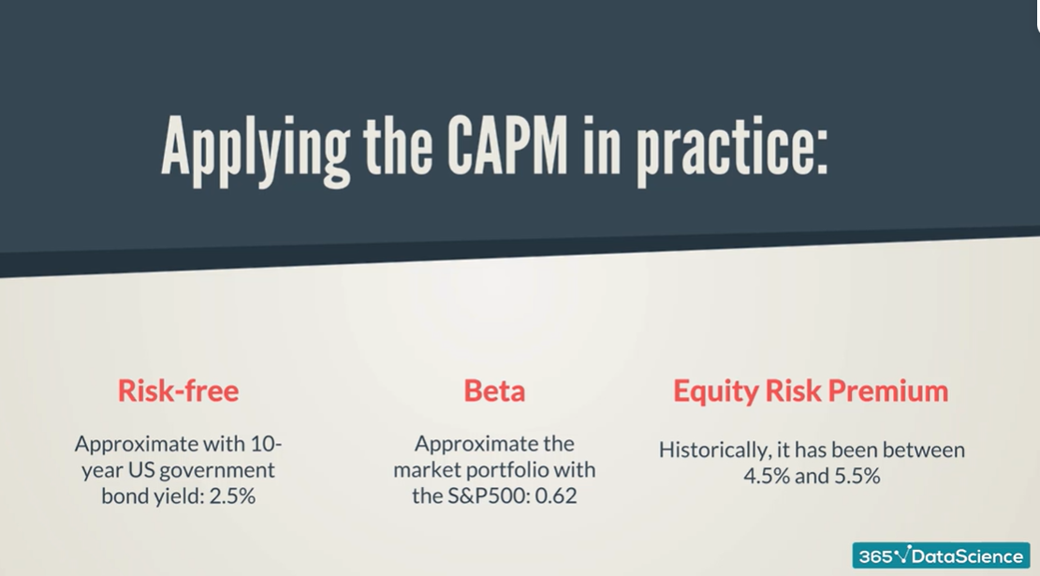

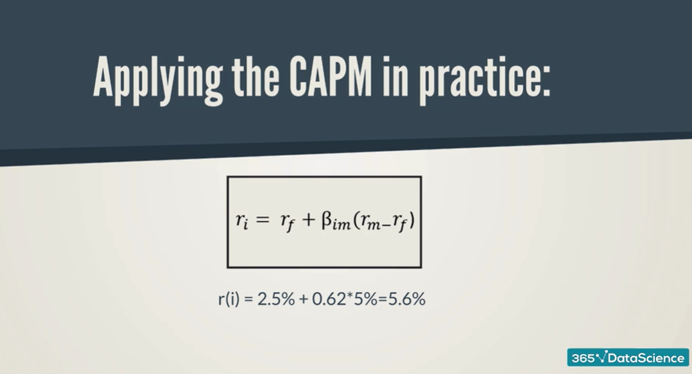

When an investor buys P&G shares he would expect to earn 5.6% to be compensated for the risk he is taking. (Most useful tool in the world of finance)

# Sharpe Ratio

Helps compare stocks and portfolios which one is preferable in terms of risk and return. The ratio measures the return on funds in excess of proxy for a risk-free guaranteed investment relative to standard deviation.

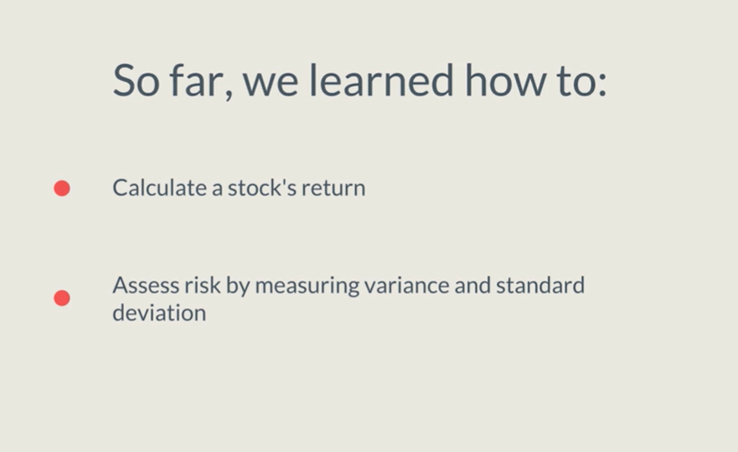

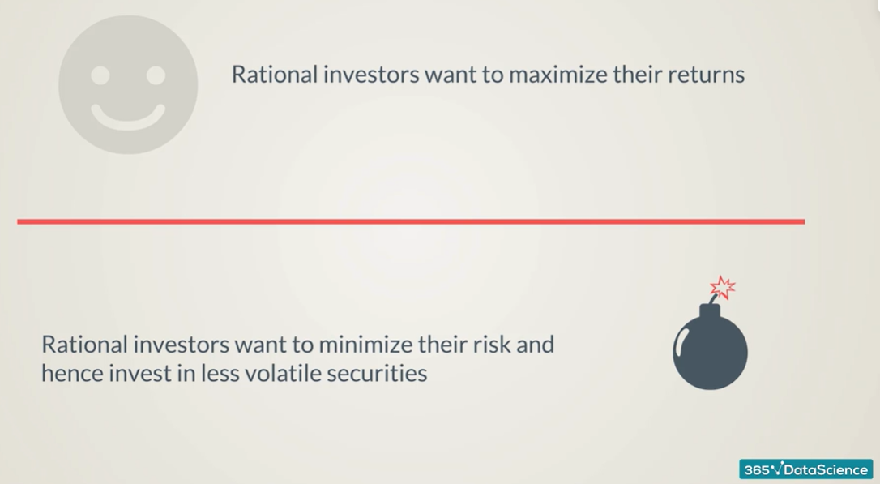







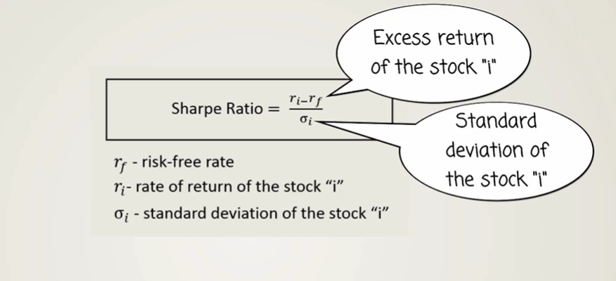

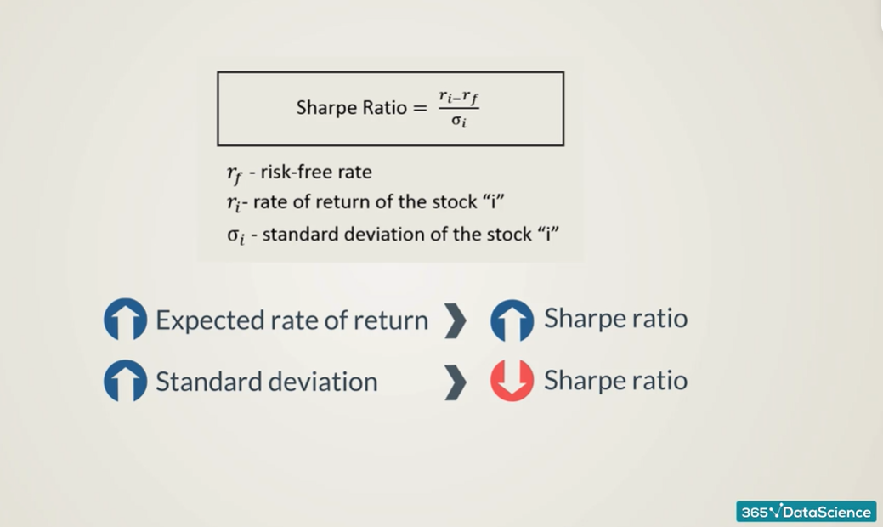



# Measuring Alpha and Verifying How Good (or Bad) a portfolio manager is doing

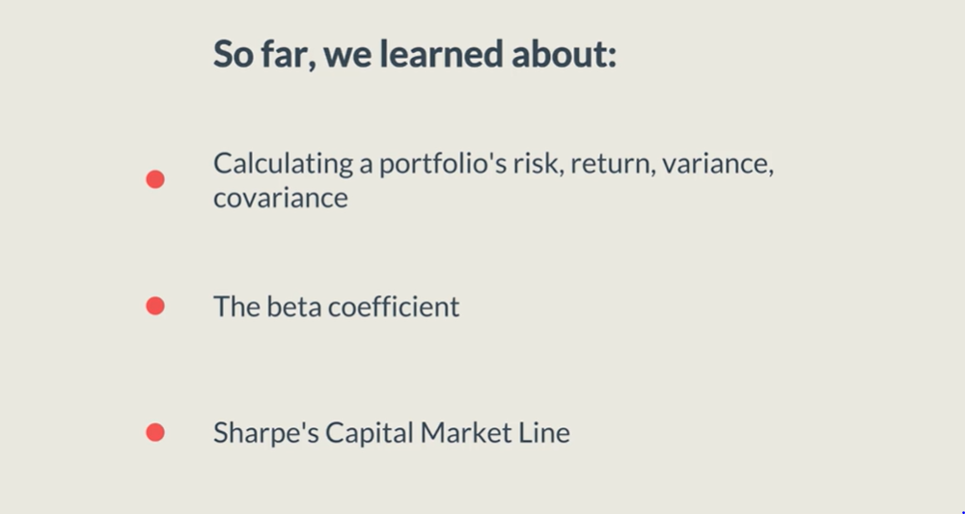

`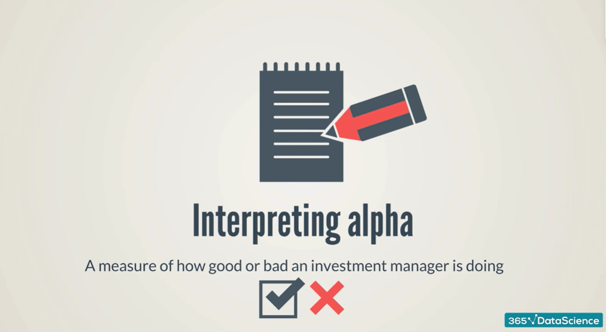

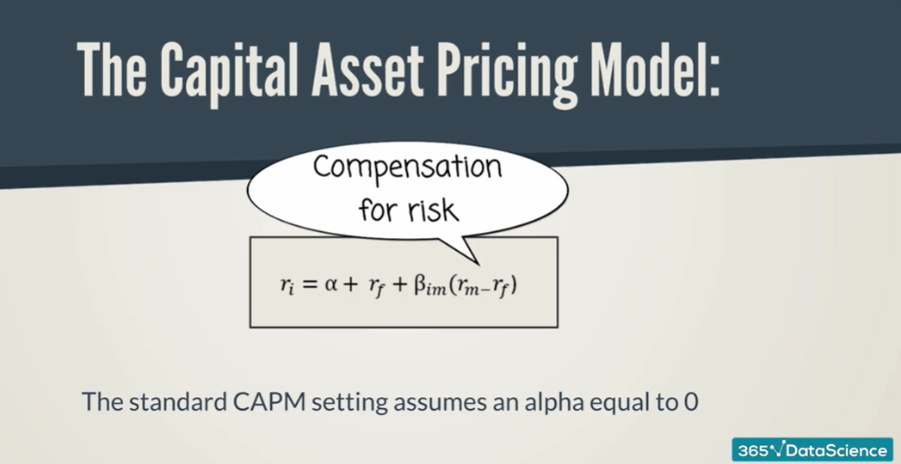







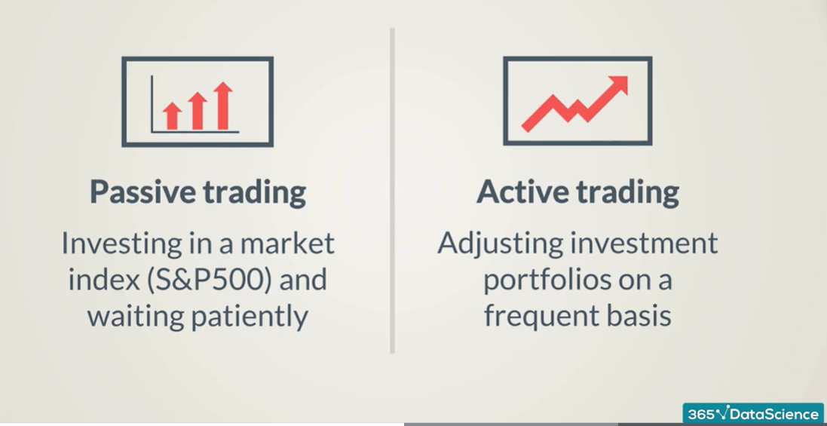

Investors take advantage of short term price changes. He don’t simply buy a stock portfolio that replicate s&p500. Take stock winning, when it normalize he would have to sell and buy other winning companies. Could vary from 1 day to several months. Active trading is the basis on which investment professional justify their fees. If investment professional charges you 1% of the investment amount, he need to outperform market by over 1% , otherwise it would be good to choose the passive trading and investor would be better off in passive trading.

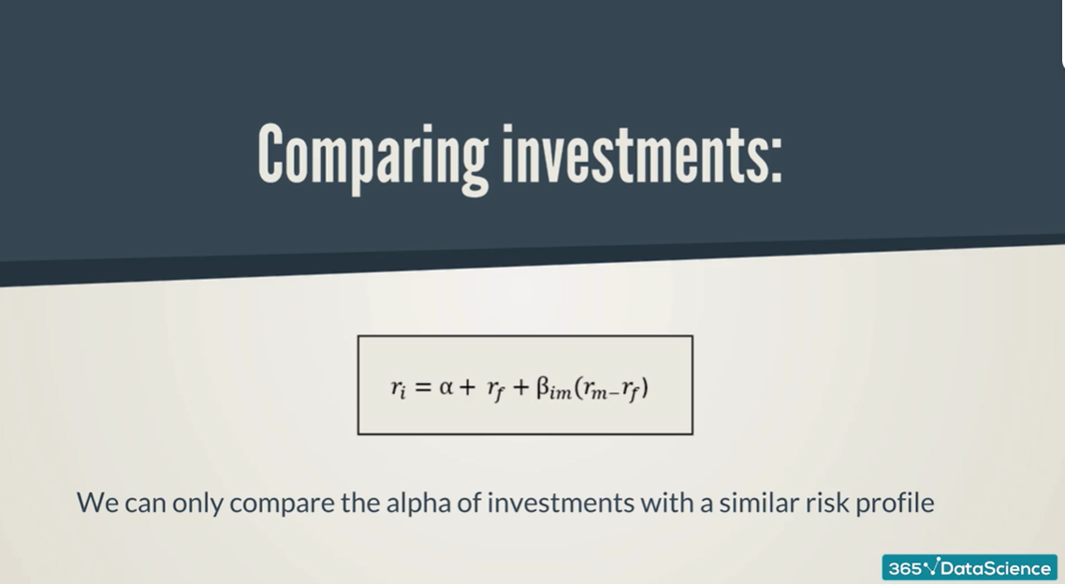

It is compared only when risk profiles of investment being compared are similar. We should not compare a portfolio of small company operating in emerging with a well-diversified of blue chip companies based on US.



Most think passive investment is good choice

William thinks that investment shouldn’t think like that and should not bother paying a small amount of fees given only 2% of the funds have positive alpha that is consistently different than 0.